State board of elections issued a covid-19 emergency order July 17, 2020 | - let your voice  - •  - be heard through your vote
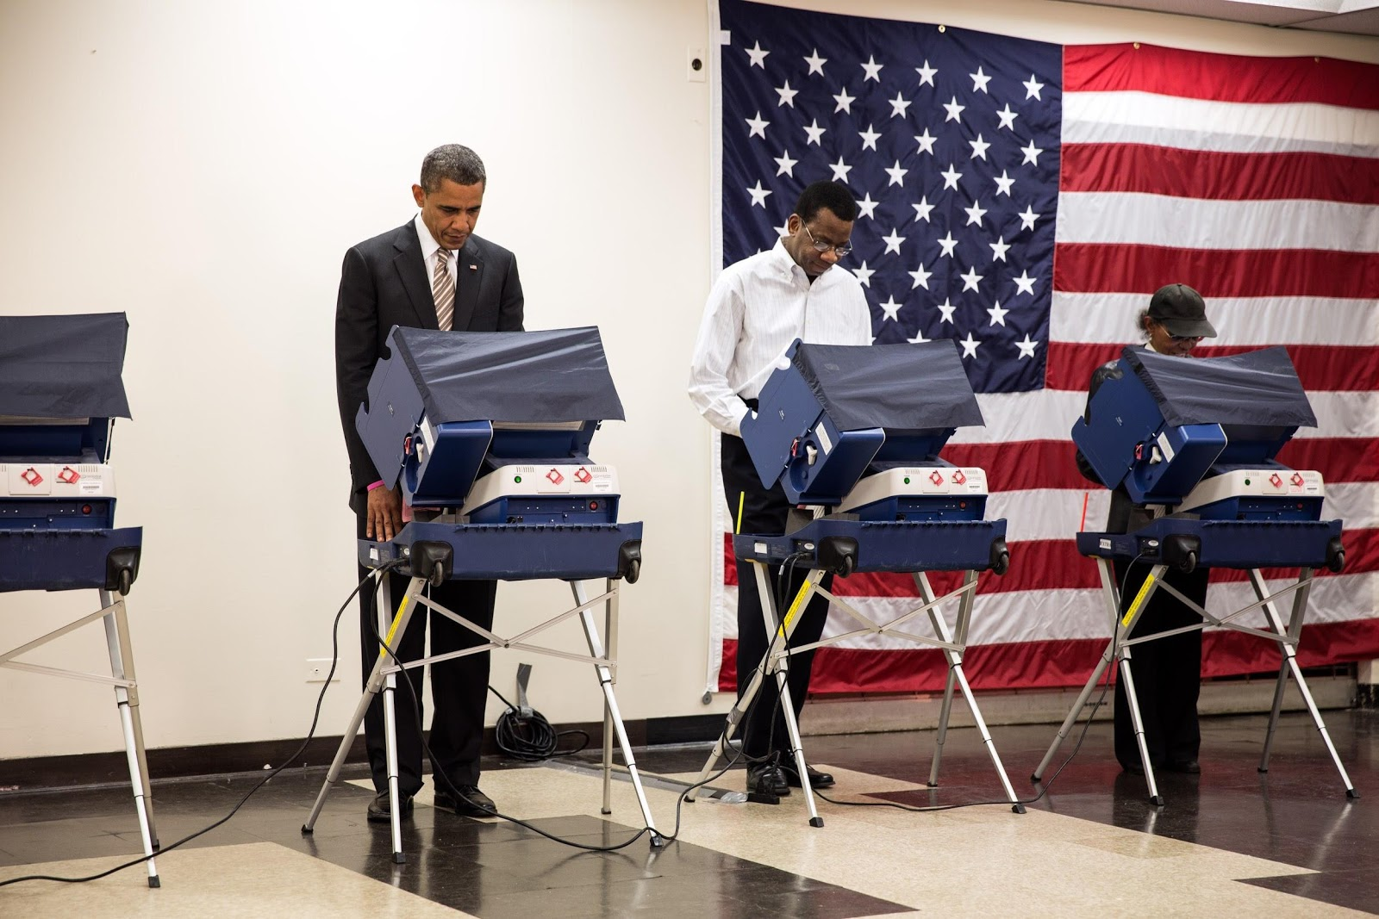  This Photo by Unknown Author is licensed under CC BY  Covid-19 Emergency Order:  Today’s order mandates the following provisions:  - All counties must open each Early Voting site for at least 10 hours on the weekends of October 17-18 and October 24-25.  - Each county must open at least one Early Voting site per every 20,00 registered voters in the county, unless its proposed plan sufficiently serves the voting population, maintains social distancing and reduces the likelihood of long lines.  - Any county board with only one Early Voting site must arrange for an additional backup site and backup staff.  - County boards will be allowed to open Early Voting sites before 8 a.m. and remain open later than 7:30 p.m., provided that all sites open at the same time.  - All county boards must take significant precautions to protect voters and poll workers from the spread of disease. These safeguards include: providing social distancing at voting sites, frequently sanitizing common surfaces, requiring elections officials to wear face coverings and making masks available to votes who do not bring their own, and more.  The purpose of this order is to allow more people to vote and to keep voters and poll workers as safe as possible. You have three options for voting in November (1) absentee ballot (2) early voting and (3) in person voting. Please make your vote count.  If you have not registered to vote then please do so, because this election every vote counts and affects our future. | This Photo by Unknown Author is licensed under CC BY

